Strategic Engagement of Local Governments in the Preparation of the National Development Strategy 2021-2041
- Aligning Local and Regional with National Development Strategies

Borce Trenovski and Aleksandar Stojkov

Contents

Executive summary 4
1. Objective of the Assignment 6
2. Context 6
3. Methodology 8
3.1. The Methodological Approach 8
3.2. Guiding Framework 8
4. Aligning local and regional with national development strategies 10
4.1. Strategic Planning at the Local Level 10
4.2. Strategic Planning at the Regional Level 12
4.3. The communication between central and local governments 14
4.4. The pivotal role of the Association of Units of Local Self-Government (ZELS) 16
5. Strategic Engagement 17
5.1. The need for strategic engagement of local government units 18
5.2. International experiences and guidelines 18
Principles in the Process of Strategic Inclusion of Local Governments 18
Guidelines for civil participation in political decision making, adopted by the Council of Europe on 27 September 2017 20
5.3. Lessons from Croatia’s National Development Strategy 2030 21
5.4. National experiences and guidelines for Stakeholder’s Engagement in National Planning 22
5.4.1. Strategy for Regional Development of North Macedonia 2021-2031 22
5.4.2. Community Forums 24
Box 1. Municipality platform “Opstinski.mk” 24
5.4.3. Screening Stakeholders’ Expectations 25
6. Policy Recommendations 25
6.1. Stakeholder mapping 25
6.2. Stages of Engagement 28
6.3. Communication Channels 28
6.4. Community Forum 29
6.5. Methodological Framework and action steps 30
6.6. Localizing National Development Frameworks 37
6.7. National aspirations and local implementation 38
6.8. The Quest for a Balanced Regional Development 38

Executive summary

- Strategic ‘noise’. There has been an over-production of strategies in the past two decades, in many cases without accompanying action plans or without secured funding. The low degree of their implementation has in turn created an environment of low expectations. Nevertheless, local governments have been willing to actively participate in decision-making and provide valuable policy input.

- Strategic planning with insufficient funding. Strategies without policy costing and without secured funding have much lower likelihood of success. Securing funding is a pre-requisite (conditio sine qua non) to move from rhetoric to policy action.

- Enhancing the cooperation. We identify a significant room for improvement of the inter-governmental consultation process. There is no consistent approach across central government (line ministries and agencies) to drawing on local authorities’ experience even from the policy initiation stage. Despite the satisfactory frequency of consultations between central government and local public officials, there is a systematic disconnect between the national and local levels, partly because of insufficient appreciation of local realities. Establishing a permanent consultation forum with quarterly or semi-annual meetings could facilitate the dialogue on local priorities and better inform the formulation of national development priorities.

- Encouraging contributions from the local governments. The most significant challenge is how to increase the percentage of accepted local government initiatives by the central government in the process of strategic planning. A widespread impression among local public officials is that their voice is heard, but not enough (source: interview with ZELS representatives, 2021). This seriously increases the risk of local governments perceiving themselves as passive observers or silent bystanders. Newly enacted strategies should spell out clearly how the contribution of local governments and the Association of Units of Local Self-Government (ZELS) has, or has not, altered policy proposals. When opinions diverge, there should be an explicit elaboration by the central government institutions why LG proposals have not been accepted.

- Localizing national development strategies. Local governments need better guidance to develop the appropriate understanding, strategies, and initiatives to localize national frameworks. In numerous cases, the financial envelopes behind the Local Economic Development plans are exceedingly small to make a visible impact. This problem can be mitigated by a better inter-municipal cooperation, by introducing a system of intergovernmental equalization grants, by better coordination with the Council for Balanced Regional Development, and by increasing the number of applications and absorption capacity of municipalities for EU grants and other donor funds.

- Balanced regional development. Development plans and strategies need to be responsive to the needs of the regional conditions with appropriate policy funding. Socio-economic disparities at the local and regional level put immense pressures on the public infrastructure and environment in the high-income regions and cause depopulation and poverty in the low-income regions. A more balanced regional economic development requires development of all regions, with some regions developing faster than others. It is not only about lowering the significant disparities, but also about supporting the drivers of the regional economic development to release the synergies among regions and finding the proper balance between cooperation and competition.

- Inclusion in the national planning process. The municipalities have not been included in the process of national planning and the preparation of National Development Strategies in the past.

- Clear definition of roles. The local development process should begin with a clear definition of roles, functions, and processes, followed by a planning, implementation, monitoring and evaluation.

- Strategic inclusion. The process could be guided by the principles in the process of strategic inclusion of LGUs with the UN Analytical Framework for Multi-Stakeholder Engagement include inclusion, covering non-discrimination and accessibility; participation, covering access to information in relation to the substance on which the engagement takes place and influence in decision-making, and accountability, covering transparency about the engagement process and responsiveness.

- The recommended methodological approach is a summary of best international and national experiences, in consultation with interviews and focus group with relevant stakeholders. International experiences from Croatia demonstrate a successful result when the principle of partnership is applied, which implies involvement of major stakeholders such as public authorities, representatives of local and regional units (regional) self-governments, economic associations, social partners, academic and scientific community, civil society organizations and the interested public. National experiences reveal that utilizing digital platforms for local communication such as opstinski.mk and tools for local stakeholder engagement such as community forums deliver successful results.

- Local Development Steering Committee. The key body of the recommended Methodological Framework is the establishment of a Local Development Steering Committee with 28 stakeholders from all levels (national, planning, local) that will report to the National Steering Committee. The chair of the Local Development Steering Committee is the Ministry of Local Self-Government.

  - At the core of the methodological framework is the establishment of seven Thematic Steering Committees, that will report to the Local Development Steering Committee. The thematic areas of the seven Thematic Steering Committees are: Environment, Education, Economy, Socioeconomic and Health, Infrastructure, Tourism, and Good Local Governance.
  - The Local Development Steering Committee should involve 20 stakeholders across all levels of government, private sector, civil society, and academia can contribute with their experience, expertise, and knowledge.

- One-size-fits-all approach should be avoided. The committee should be the main policy platform for articulation of local priorities to assist in defining what specific knowledge, skills, experience, in addition to competencies and diversity elements.

- There must be a professional and persistent administrative capacity at the national and local level to manage processes, and the initiatives must be sufficiently robust and attractive to obtain the allocation of resources for scaling-up.

Objective of the Assignment

A long-term National Development Strategy for the 2021-41 period (hereinafter: NDS) is being prepared with a technical assistance from the UN family (through UNDP), and financially supported by the British Embassy. This national policy document would offer an enabling environment to facilitate the consensus on strategic priorities that would address the key challenges the country is facing, reflecting cross-generational, cross-party, cross-ethnical, and gender-balanced consensus on the national development vision over a period of 20 years.

The objective of this assignment is to provide expert level analytical and policy input to the documents created for the purposes of development of the National Development Strategy 2021-2041, with special focus on the interplay between local development and the national development strategy. It provides recommendations for constructive involvement of local governments in the national planning process. The purpose of this document is to define the types of stakeholders involved in the process of strategic engagement of the municipalities, specify the frequency and type of communications, suggest tools for communications and define a framework for this process.

The ultimate goal is to provide the relevant stakeholders with an overview of the strategic engagement in the process of preparing National Development Strategy in all phases (preparation, implementation, monitoring and evaluation) to ensure efficient engagement, as well as a high-quality and ‘living’ National Development Strategy, that will be built upon the principles of inclusion, participation, and accountability.

It also provides guidance on how local government units (LGUs) and other relevant stakeholders are going to be engaged in preparing the National Development Strategy, as stakeholders’ engagement is one of the backbones of the whole strategy and essential part of its successful accomplishment.

Context

Strategic ‘congestion’. The launch of NDS comes in an environment saturated of ‘strategic’ documents. There has never been a lack of national strategic documents in North Macedonia (Figure 2). Often, however, this has been with little reference to the administrative capacity, policy costing, secured funding, and other implementation difficulties. Additionally, limited linkages among strategies are restricting the utilization of interdependencies and synergies among different strategies. If not operationalized properly and/or poorly implemented in practice, even marvelous strategic documents would remain untapped. Commonly found problems in the implementation of strategies are: (i) excessive generalization of the main recommendations, particularly when the strategies are not followed by action plans, (ii) lack of clear responsibilities and ineffective coordination among key stakeholders, (iii) little attention to policy costing and available funding, and (iv) limited policy attention to ex ante analysis and ex post evaluation of their effects, to inform the next cycle of the policymaking process.

Figure 1. The Universe of National and Local Strategies in North Macedonia
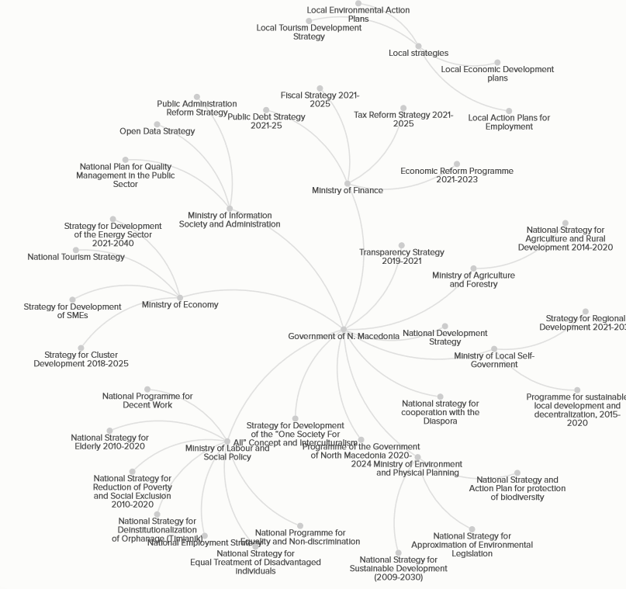

Furthermore, there is a limited ownership of previously enacted strategic documents by incumbent government cabinets or elected local officials. In general, the commitment to a medium- or long-term strategic document, enacted by the predecessors is exceptionally low. The political culture nurtures a perverse tradition in which discontinuity and novelty are considered as the appropriate start of the strategic planning process. This leads to a significant loss of institutional knowledge or institutional memory.

Inclusiveness of the process. Since the payoff of reforms is often beyond election cycles, authorities should aim to promote an effective dialogue across the political spectrum. Also, involving the business community, civil society, and international development partners is an exceptionally important prerequisite for an inclusive approach to the design and implementation of the all-embracing National Development Strategy, the multi-sector or single-sector development policies.

The strategic engagement of the local government units in preparing the National Development Strategy 2021-2041 requires a stakeholders’ engagement strategy. The latter is a strategy designed to shape and conduct the active involvement and participation of stakeholders in the implementation of a project, initiative, or campaign. This document sets the foundation for a contemporary methodological framework, which maps all relevant local stakeholders and implement and proposes a methodology for their engagement in the creation process of the NDS.

Methodology

The Methodological Approach

This document is based on a contemporary methodology, combining both traditional and innovative approaches and relying on best international practices and the expertise of many stakeholders in the country (at the national, regional, and local level). To understand the factors that affect communication in the strategic planning between central and local governments and identify good practices, we review national and local strategic documents, conduct local government reviews (by telephone mainly), and conduct surveys of elected local public officials. The literature review takes into consideration different strategic documents and best practices from the country and abroad.

The proposed methodology is a result of international and national experiences, quantitative research with different local societal stakeholders (survey analysis) and qualitative research analysis, with insight from the expectations of key stakeholders in local governance in North Macedonia. The methodological approach is a summary of best international and national experiences, in consultation with interviews and focus group with relevant stakeholders. For instance, the international experiences from Croatia demonstrate a successful result when the principle of partnership is applied, which implies involvement of major stakeholders such as public authorities, representatives of local and regional units (regional) self-governments, economic associations, social partners, academic and scientific community, civil society organizations and the interested public.
National experiences reveal that utilizing digital platforms for local communication such as opstinski.mk and tools for local stakeholder engagement such as community forums deliver successful results. The Methodological framework is extracted from different sources and in this report only the key documents, which aspects, topics, and principles were used for the methodology are presented here. Furthermore, a qualitative research was conducted, where key local, regional, and national stakeholders were interviewed (1:1) regarding their experience and knowledge regarding stakeholder engagement of the municipalities in national planning.

Guiding Framework

Our guiding framework is the Integrated Local Governance and Local Development (LGLD) Framework, one of the initial forms of support from the UN system, intended to assist the partners across societies and economies at various stages of development. This framework gives insight into different perspectives and knowledge related to interventions and approaches on how to engage local stakeholders in global and national development strategies.

The framework consists of four key inputs: (1) the enablement of democratic liability founded on inclusive civil practices and empowered citizen voices; (2) strong foundation of the rule of law protecting the civil rights and securing all of the available legal mechanisms; (3) the development of essential administrative capacity for development management and services; and (4) enabling important fiscal tools and resources, and facilitation of social capital formation.

LGLD framework provides methodology for an influence of the local development initiatives at national level, by helping the local sustainable development processes. The local development process should begin with a clear definition of roles, functions, and processes, followed by a planning, implementation, monitoring and evaluation. These tasks require high level policy advisory inputs, to ensure that the issues related to localization of the SDGs are appropriately addressed. Sectors related to sustainable human development at the local level will be prioritized. Recommendations set up for these sectors are:

- providing capacity support for the development of sector-specific indicative plans and the setting of standards and guidelines
- facilitating sector-wide responses and cross-sectorial dialogues
- facilitating the participation of the private sector and civil society in participation in and influencing sector-specific responses to the national and local development strategy.

Sustainable and inclusive local development planning facilitates three important processes:

- Collecting and aggregating the problems and needs of the local population, with the aim to be addressed in national strategies and sector programs
- Data analysis and creation of targets and strategies for regional development plans
- Balancing local goals with the national strategic priorities.

The appropriate implementation of the local development plan can ensure that investments, projects, and services are delivered with meaningful (not only formal) community involvement. At the community level, the three areas identified in the framework (engagement, implementation, and accountability), are key to the process (Figure 1).

Six key capacities were defined, which are seen as necessary to operationalize local engagement for: (1) steering a national visioning process; (2) sector-specific development planning; (3) steering the sub-national development planning process; (4) managing territorial partnerships and exchanges; (5) fostering social cohesion and heterogeneous society; and (6) knowledge management and advocacy.

LGLD also provides a set of initiatives, which are relevant to the strategic engagement of the municipalities in the process of preparing the NDS:
• development of a harmonized LGLD work plan at the country level
• appointment of a focal team at the country level to coordinate LGLD country tasks
• creation of an integrated LGLD funding mechanism for programme implementation at the local level with defined criteria for access; and
• availability of a knowledge hub for tools and guidelines to support LGLD at the country level.
Figure 2. Development process at the national level and entry points for support
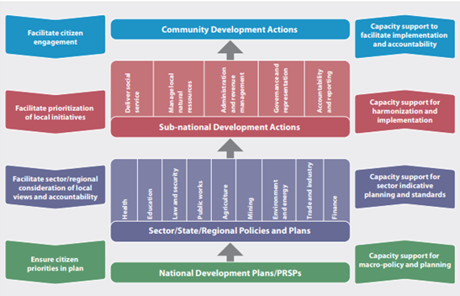

Another early recommendation relevant for the strategic engagement of the municipalities in the process of preparing the NDS is to create multi-disciplinary development solution teams, at different levels in order to involve stakeholders with a range of skills and knowledge. These multi-disciplinary teams can provide an optimal mix of support to national governments. Additionally, important recommendation is to set up territorial platforms which will facilitate the implementation of multi-disciplinary and multi-actor LGLD initiatives at the regional and local level.

Aligning local and regional with national development strategies

Strategic Planning at the Local Level

From a strategic point of view, local governments are expected to balance their local priorities with the need to deliver national objectives.

Legal responsibility and public accountability. Municipalities are becoming increasingly aware of the benefits of the local development (strategic) planning. The development planning process stems not only as an obligation from Art. 22 of the Law on Local Self-Government, which envisages that “municipalities shall be responsible for urban and rural planning, as well as for the planning of the local economic development”, but also due to the increased democratic pressure from the electorate for a greater public accountability at the local level. Apart from this broadly defined legal responsibility, there is no further - more specific - guidance on the design of an integrated system of strategic planning at the local level.

Main strategies / planning documents. The strategic planning at the local level commonly produces several documents: (a) a comprehensive development plan often called a Local Economic Development (LED) Plan; (b) multi-sectoral (though not entirely comprehensive) strategies such as a rural development strategy/plan or a Local Action Plan for Employment (LAPE); and (c) single-sector development strategies/ plans, focusing on certain areas of the development, such as the Local Environmental Action Plan (LEAP), the Tourism Development Strategy, etc. A very brief elaboration of their main objective is in order (see also Figure 3).
- Local Economic Development (LED) plans are often prepared by the municipalities themselves either without or with little coordination with the national institutions. In numerous cases, the budgeted amounts are very small to have a visible impact on local economy. Still, if matched with donor funds and/or nationally coordinated investment spending projects, LED plans have a strong potential for a more meaningful impact on the welfare of local communities. With UNDP support, 30 small urban and rural municipalities prepared Integrated and Inclusive Local Development plans (instead of LED). Methodology for integrated and inclusive local development planning has been prepared as well.
- Local Environmental Action Plan (LEAP) - or sometimes more specifically defined as a Clean Air Strategy - provides relevant information to citizens and potential investors on measures to address negative environmental impacts.
- The Local Action Plan for Employment (LAPE) is often based on a detailed database of the demographic structure and the labor force in the municipality (number and composition of employed and unemployed persons in the municipality).
- The Tourism Development Strategy is often produced by municipalities that are established tourism destinations (e.g., Ohrid, Struga and Dojran) or have tourist attractions (e.g., Waterfalls in Smolare, Novo Selo). Ten municipalities were supported by the National Tourism Strategy of the Ministry of Economy to develop local strategies for alternative tourism and wine tourism (Kavadarci, Negotino, and Demir Kapija). One of the main goals should be better coordination of tourism development and to have a regional (destination) approach to development, not local (municipal). This makes sense because tourists do not see the holiday destination within administrative boundaries.
- Rural Development Strategies/ Plans are developed to address the development of economic activities in the rural settlements in the municipal territory.

Small financial envelopes. In numerous cases, the financial envelopes behind the Local Economic Development plans are small enough to make a visible impact.

Risk of limited ownership over the strategies. The preparation of these development plans is often outsourced to experts from non-governmental organizations, academic institutions, or consultancy firms, which may increase the risk of limited ownership over the documents and the commitment for their implementation.

The time horizon of these development plans is very diverse, as it spans either over the medium term: (i) three years (e.g., Bitola and Strumica) and (b) five years (e.g., Berovo, Pehcevo), or the long term (from nine years in the case of Mavrovo and Rostuša) to 11 years (such as the Smart City Plan of Veles 2019-2030).

Participatory process. The municipalities are obliged to establish mechanisms for citizens’ participation in the preparation of strategies, according to Art. 21 of the newly proposed Organic Budget Law (in parliamentary procedure in April 2021).

Figure 3. Types of local strategies

Strategic Planning at the Regional Level

Strategic documents and institutional structure. The new Law on Balanced Regional Development (24/2021) envisages a ten-year Strategy for Regional Development and three-year action plans on a rollover basis. The institutional structure consists of a nation-wide Council for Balanced Regional Development, councils for the development of each planning region consisting of all mayors and a Bureau for Regional Development, a body within the Ministry of Local Self-Government (Figure 4). Each planning region has its own Center for Development of the Planning Region.

Figure 4. The institutional structure supporting the aim of balanced regional development
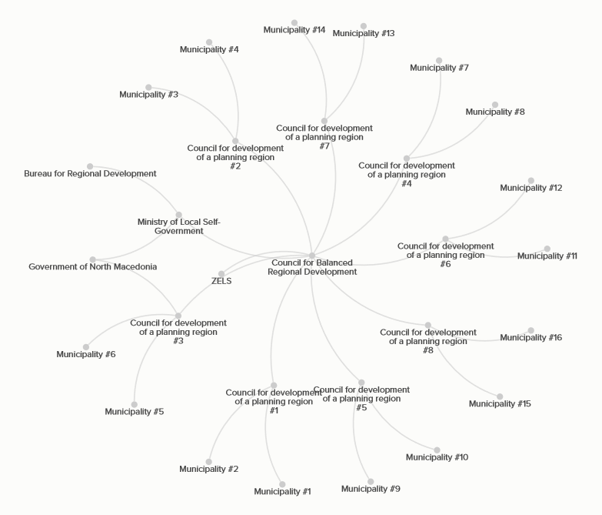

The previous strategy for balanced regional development was ineffective so far. North Macedonia has eight statistical regions for development planning purposes (NUTS-3 level) . The socio-economic disparities among regions are stark and gaps have been widening in absolute terms: GDP per capita of the Skopje region was three times larger of the GDP per capita in the Polog region in 2019. The max-min ratio between Skopje and Polog regions was fluctuating between 2.6 and 3.4 times in the past 20 years. Despite numerous development strategies and a separate strategy for balanced regional development in place, a heavily imbalanced regional development is a reality since country’s independence.

Figure 5. GDP per capita of statistical regions in north Macedonia (2000-19)

Source: Based on data from the State Statistical Office (May 2021).

Insufficient funding. The official rhetoric in favor of balanced regional economic development in the reality loses its momentum at the level of strategy. The all-time high of budgetary funds allocated for a balanced regional development was a small amount of 9.2 Million Euros, as envisaged by the National Budget 2021. According to Article 27, item (2) of the Law on Regional Development, the legally prescribed minimum of budgetary funds allocated for alleviating the imbalanced regional development is 1% of GDP (equivalent to 115.9 Million Euros in 2021). Such a practice points to a huge discrepancy between the strategic intentions for regional development and actual policy funding.

Implications. Socio-economic disparities at the local and regional level put immense pressures on the public infrastructure and environment in the high-income regions and cause depopulation and poverty in the low-income regions. A more balanced regional economic development therefore requires some regions to grow faster than others. It is not only about lowering the significant disparities, but also about supporting the drivers of the regional economic development to release the synergies among regions and finding the proper balance between cooperation and competition.

The communication between central and local governments

As the delivery of local public services becomes an ever-greater concern of central government, how central government (ministries and agencies) and local government communicate with one another becomes all the more important. The current practice (mostly acquired through interviews and anecdotal evidence) suggests limited effectiveness of central government’s communication and engagement with local government.

Institutionalized cooperation. The Association of Units of Local Self-Government (ZELS) has signed a formal memorandum of cooperation with the Government of North Macedonia, containing provisions for mandatory involvement of ZELS in the consultation process for adoption of new, or changes to existing legislation. High representatives of ZELS have expressed a great satisfaction from their involvement in the consultation process with the central government. ZELS and the municipalities receive a number of strategic documents, acts, and by-laws for comments.

A voice not being heard enough. However, the overall impression is that “their proposals will most likely not be taken into account and will not lead to a change of the reality”. The limited number of proposals being accepted by the central government merits an investigation on its own.

Rushed public consultations. Consultations with the local governments sometimes are not timely, i.e., come at a late stage of the preparation of the document.

Information gaps. In some cases, local governments have gaps in the information they need to provide an input to the central government’s institution. For instance, proposing a reform of the system of intergovernmental fiscal transfers may require more information on the overall fiscal envelope, timescale, horizontal fiscal imbalances, etc. More seriously, information gaps or delayed information may harm their ability for effective planning or implementation.

Style of ‘command and control’. The anecdotal evidence suggests that administrative staff of local governments believe that central government officials do not sufficiently understand local government priorities, structures, and business well.

The curse of a political divide. Different political affiliations between the elected local officials and the government coalition will most likely lead to a lack of effective communication with the central government.

Other communication problems. A survey by OSCE (2016) identified several other communication problems, including lack of by-laws and more specific guidance (29.6%), slow response to local government initiatives (27.8%), no access to, or no contact person (14.8%), lack of sufficient information on institutional websites (13.0%) (Figure 6).
Figure 6. Communication problems for local public officials and local public administration

The pivotal role of the Association of Units of Local Self-Government (ZELS)

The Strategic Plan of ZELS. The Strategic Plan 2021-2025 of the Association of Municipalities (ZELS) contains three strategic goals, the first one being to ensure mechanisms for advocacy and lobbying for its members (the municipalities) within the “dialogue between the central government and the municipalities”. The Strategic Plan envisages a design of Communication Protocol with the central government by the end of 2022.

The role of local government associations. A survey among 50 local public officials was conducted by the authors in 2019, sponsored by NALAS (Network of Associations of Local Authorities of South East Europe). The goal was to assess the role and involvement of Local Government Associations (LGAs) in strategic planning and policy dialogue in ten countries from South Eastern Europe (Albania, Bosnia and Herzegovina, Bulgaria, Croatia, Kosovo, North Macedonia, Moldova, Montenegro, Romania, and Slovenia). Their role was assessed along five dimensions: (i) LGA positioning for strategic planning and policy dialogue; (ii) LGA consultation with its members (the local self-government units); (iii) inter-governmental consultation practices; (iv) perceived impact of LGA’s proposals; and (v) LGA involvement in policy dialogue at the international level. We confine the analysis only to the role of ZELS in North Macedonia (Table 1).

Legal position. North Macedonia ratified the European Charter of Local Self-Government in 1997 and an additional Protocol was ratified in September 2015. Article 3 of the Charter stipulates that the local authorities must have the right and ability “to regulate and manage a substantial share of public affairs” and, Article 4 that, “the powers given to local authorities shall normally be full and exclusive”. It is difficult to exercise these responsibilities when finance does not always follow function. Surveyed local public officials assess that the role of ZELS in the Law on Local Self-Government is very broadly defined in Article 8.
Table 1. Self-Evaluation of Local Government Associations’ Involvement in Policy Dialogue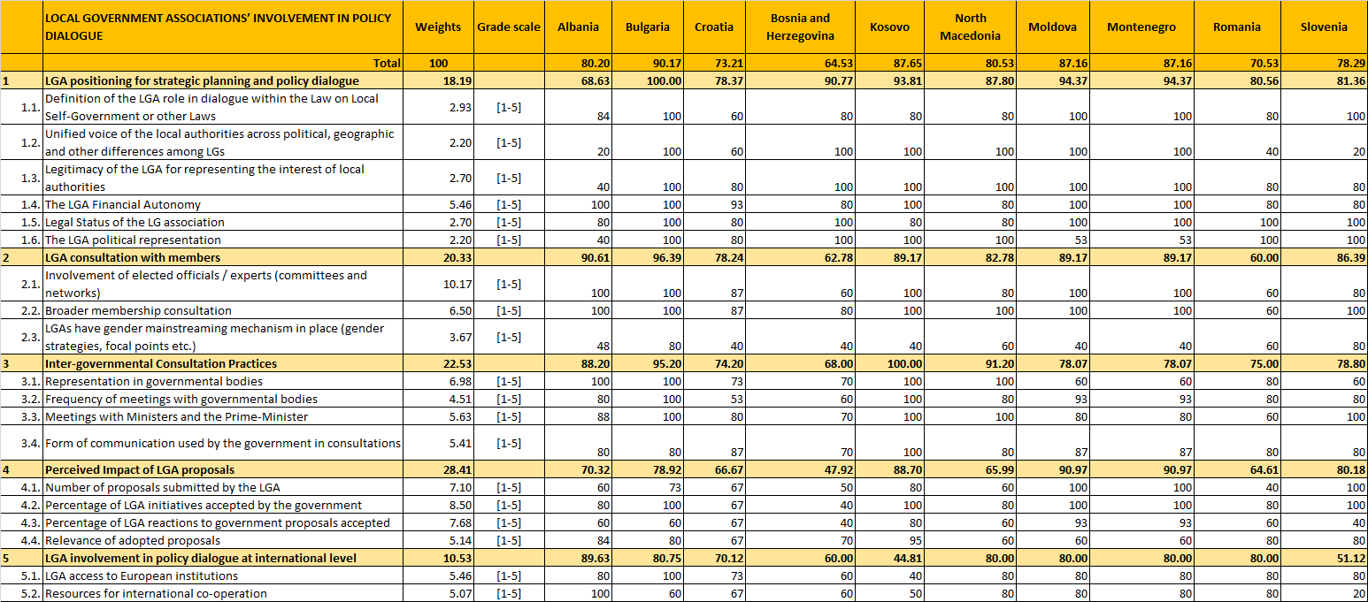
Source: Authors’ work on the Regional Decentralization Observatory (RDO) project by NALAS (2019).
Insufficient appreciation of the input. ZELS administration reports a low to moderate percentage of accepted initiatives accepted by the central government as well as limited appreciation of their feedback to government strategies and proposed legislative changes. The impression by local government officials is also shared by ZELS representatives.

Inter-governmental consultation practices. Local public officials prefer more frequent contacts among ZELS, local public officials, and central government officials.

Improving the level of appreciation. There is a significant room for improvement in terms of the percentage of initiatives by ZELS accepted by the central government. A common response in our interviews of ZELS officials is “they will certainly invite us for consultations, but only a very few of our proposals will be accepted”.

Strategic Engagement

The guidelines for strategic engagement of local governments are prepared in line with UNDP-UNDESA. We also provide a concise reference to the national legal framework, strategic documents, previous research findings and analysis regarding the gaps in the strategic engagement of the municipalities when making national strategies, as well as introducing new recommendations for improvement. Furthermore, the project management structure, tasks, responsibilities, and procedures at all levels of municipalities’ engagement, are defined.
Additionally, this document comprises documentation and communication standards in order to enable quick and efficient communication within the municipalities and between the municipalities and the national governance as well.
“Effective committees don't just happen. They are a combination of the right individuals, a mission, good leadership, and good staff work.”

The need for strategic engagement of local government units

Local governments have not been included in the process on national planning and the preparation of National Development Strategies in the past. The current national legislation does not require their involvement in planning and decision-making process regarding set goals.
Developing capacity for engagement of local stakeholders in national planning is essential not just for the preparation of the NDS, but also to support the process of making the central government more responsive, accountable, and inclusive toward the local stakeholders. Furthermore, the methodological framework can be utilized for additional stakeholder engagement activities in the regular work activities of the central government.
The holistic nature of NDS requires a multi-sectorial perspective to understand the relationships between the local key players, development issues and challenges, potentials, and perspectives. The choice of approach has to be adapted to the local development context and political system and depends on a philosophy that provides a conceptual but also, most importantly, a practical response to development needs. The conversion of national sector policies into local policies requires an effective decentralization process and the active participation of all stakeholders—including civil society, the private sector, and local authorities.

International experiences and guidelines

Different strategic documents, guidelines and recommendations were taken into consideration for creating the methodology for inclusion of LGUs in the process of national strategic planning. This methodology is built on principles which are determined and accepted by UN and Council of Europe.

Principles in the Process of Strategic Inclusion of Local Governments
The UN’s 2030 Agenda for Sustainable Development and its Sustainable Development Goals (SDGs) assigns a significant role to the diverse stakeholders in implementation. The UN Department of Economic and Social Affairs created a framework for quality stakeholder engagement. The framework can be applied: (1) to diverse mechanisms for stakeholder engagement; (2) at different stages of the SDG-cycle, such as policy formulation, implementation, monitoring, reporting and follow-up; (3) to assess the quality of engagement practices as well as identify lessons learned and recommendations to improve practices.
The framework is based on three key principles, including two dimensions each: inclusion, covering non-discrimination and accessibility; participation, covering access to information in relation to the substance on which the engagement takes place and influence in decision-making, and accountability, covering transparency about the engagement process and responsiveness
The framework’s essence is extracted from different sources: the 2030 Agenda, the SDG 16, an existing literature body on the quality stakeholder engagement produced by the UN agencies, and the experiences of local governments, CSO’s and other stakeholders.
For each dimension of the framework, four levels are identified on a continuum to represent increasing levels of quality stakeholder engagement.
The zero level includes very limited efforts within the quality of the stakeholder engagement. In the matter of non-discrimination, the implementer of the practice makes no effort to engage a diverse range of sectors and actors, especially municipalities that are traditionally left out of decision-making and policy-making processes (smaller and financially weaker municipalities). In the matter of accessibility, the implementer of the practice does not address accessibility issues such as safety and security of vulnerable groups. In the matter of access to information, the implementer of the practice does not provide publicly official data or information. In the matter of influence in decision-making, the implementer of the practice does not involve stakeholders at any point of decision-making processes. In the matter of transparency, the implementer of the practice does not share any public information on process, including timelines, stakeholders involved and institutions responsible. In the matter of responsiveness, the implementer of the practice does not offer stakeholders the possibility to provide feedback on how the process reflects the principles of inclusion, participation, and accountability.
Concerning the first level of non-discrimination, the implementer of the practice occasionally invites few groups (often the same). Others that are affected by the issue are not openly invited and resources have not been allocated to support inclusion. Accessibility has been identified as a requirement and implementer of the practice allocates enough resources to address accessibility requirements upon request or on an ad hoc basis. In the matter of access to information, the implementer of the practice provides information upon request, but the initial contacts or data is available only to a limited group. Concerning the influence in decision-making, the implementer of the practice asks stakeholders for comments occasionally and ad hoc. In the case of information transparency, the implementer of the practice provides limited information on the process publicly or upon request, resulting in unclarity about the address of the contact point, and the limitation of the chosen stakeholders that are provided with the full information. Concerning responsiveness, the implementer of the practice receives feedback on the process.
Figure 7: Principles and Dimensions of the UN Analytical Framework
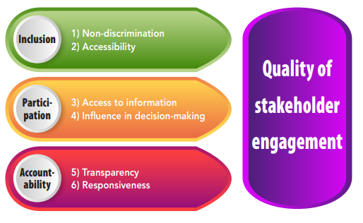
Source: https://www.undp.org/content/undp/en/home/librarypage/capacity-building/accountability/multi-stakeholder-engagement-processes.html
About the second level of non-discrimination, the implementer occasionally identifies the sectors and actors that are left behind and should be engaged. The implementer includes stakeholders that have selected their own representation and secures resources to facilitate inclusion. In the field of accessibility, the implementer of the practice identifies accessibility concerns early on and uses this information to design the engagement process with resources allocated as necessary. Concerning the information access, the implementer of the practice provides occasional information, through a social media, website, or platform. Concerning the decision-making influence, the implementer of the practice consults stakeholders on regular basis. There are some elements of collaboration, but the stakeholders do not actively participate in most of the decisions. The information on the process is provided publicly and is being followed and the implementer of the practice receives feedback on the process from stakeholders and promises to redress weaknesses.
Concerning the third level, the best outcome of the non-discrimination would be if the implementer of the practice identifies diverse sectors and actors left behind, includes stakeholders that have selected their own representation, includes diverse actors and those most left behind in the design of the process, allocates sufficient resources for those furthest left behind in the design process. Concerning accessibility, the implementer of the practice creates a system to identify accessibility requirements on an ongoing basis in consultation with stakeholders; uses information regarding accessibility to design the engagement process alongside stakeholders; and makes resources available to reduce barriers to the maximum extent possible. Concerning the access to information, the implementer of the practice produces and shares relevant information and data publicly ahead of decisions with sufficient time to consult constituencies and opportunity to react; produces and shares information on practice progress jointly with relevant stakeholders and explains how differing views are being dealt with. Concerning the decision-making influence, the implementer has mechanisms that allow for partnership and co-creation with stakeholders in agenda-setting and decision-making processes; explains how inputs that have been received have been used and have impacted outcomes; addresses power imbalances between stakeholders are addressed, e.g., capacity development. Concerning the transparency, the implementer of the practice does all of the following, makes information on the process widely available, so that stakeholders, parliament, and media are informed; follows the process; explains how diverging views/inputs are being dealt with.
Concerning the responsiveness, the implementer of the practice provides a robust mechanism to encourage stakeholders to present feedback and grievances on how the process reflects the principles of inclusion, participation and accountability; and redresses weaknesses of the processes with relevant stakeholders.

Guidelines for civil participation in political decision making, adopted by the Council of Europe on 27 September 2017
Principles from the guidelines which are relevant for the Strategic engagement of the Municipalities in the process of preparing the National Development Strategy are:
- mutual respect between all actors as the basis for honest interaction and mutual trust
- respect for the independence of NGOs whether their opinions are consistent with those of the public authorities or not
- respect for the position of public authorities with whom responsibility and accountability for decision making lies
- openness, transparency, and accountability
- responsiveness, with all actors providing appropriate feedback
- non-discrimination and inclusiveness so that all voices, including those of the less privileged and most vulnerable, can be heard and considered
- gender equality and equal participation of all groups including those with particular interests and needs, such as young people, the elderly, people with disabilities or minorities
- accessibility through the use of clear language and appropriate means of participation, offline or online, and on any device.
The same document provides number of fundamentals, on which the civil participation in political decision-making should take place and here we point out the key relevant fundamentals for the Local engagement:
- Public authorities should plan and manage civil participation and clearly define the objectives, actors, process, and timeline, as well as the methods used.
- Public authorities should provide up-to-date, comprehensive information about the decision-making process and procedures for participation.
- Public authorities and NGOs may wish to conclude framework agreements for co-operation to support civil participation.

Lessons from Croatia’s National Development Strategy 2030

The most adequate comparative example in the region is the Croatian National Development Strategy 2030. The Croatian model allows the measurement of the performance of diverse measures, projects and activities defined in the strategic documents of public authorities at the national, regional, and local levels.
The topics treated in the National Strategy are:
Topics
Health | Energy | Transport | Environment | Labor market
Macroeconomic stability, fiscal policy and taxation | Growth, competitiveness, and innovation | Family policies | Regional availability of social services | Tax breaks for children and suggestions for improvements
Education and skills | Modernization of public administration | Management of state property | Justice sector | Territorial development

These topics were taken in consideration when defining the themes for the Thematic Steering Committees, as part of the Methodology Framework for Strategic engagement of the Municipalities in the process of preparing the National Development Strategy 2021. The analytical backgrounds of the topics are summarized in a single report with an overview of the areas in which there is a need to intervene through public policies.

The Croatian National Strategy was developed in four phases:
1. Development of national vision and directions until 2030.
2. Definition of strategic objectives, key areas of intervention and impact indicators
3. Definition of implementation mechanisms, structural reforms and strategic projects
4. Definition of the financial framework and the overall framework for implementation, monitoring and strategy evaluation.

During the drafting process, the principle of partnership has been applied, which implies involvement of major stakeholders such as public authorities, representatives of local and regional units (regional) self-governments, economic associations, social partners, academic and scientific community, civil society organizations and the interested public.

The schematic structure of the stakeholder engagement in Croatian National Development Strategy 2030 can be found in Annex 3. The following stakeholder engagement bodies were formed:
- Steering Committee for the drafting of the NRS, consisting of the Prime Minister and all ministers, representatives of the Croatian Parliament, the Office of the President of the Republic, the Croatian Community County, Association of Cities in the Republic of Croatia, Croatian Association of Municipalities, Association municipalities in the Republic of Croatia, Croatian Employers' Association, Croatian Economic Association Chamber, Croatian Chamber of Trades and Crafts, higher level trade unions, Croatian National Bank and Croatian Academy of Sciences and Arts. The Committee’s role is to guide and supervise the whole process of drafting of the NRS.
- Interdepartmental working group for NRS drafting consists of seven thematic working groups (health and quality of life; energy and sustainable environment; traffic and mobility; security; food and bio-economy; digital society, tourism and creative society) and five working groups for horizontal policies (territorial development; macroeconomic policies, judiciary and good governance; education, science and development human resources; demography and social policies; competitiveness, industrial development and development of entrepreneurship and crafts). As part of the working groups there were representatives from local and regional self-government units, regional coordinators and other stakeholders from the regional and local level.
- County development forums attended by representatives of relevant institutions on county level and regional coordinators that take care about the territorial NRS access. The aim was to define long-term visions for the development of counties and to better identify their development issues and potentials, the key economic branches and strategic development projects.
- Participatory workshops – county representatives of the public, business, scientific-research and civil sector. They were held in cooperation with the regional coordinators, and their goal was to exchange opinions and views on future development.
- Leadership groups of representatives of the business sector, which include representatives of private companies from relevant sectors that could contribute to the development of the NRS.
- Focus groups for strategic projects / programs, whose task was to develop action plans for the preparation of project documentation for strategic projects and implementation plans with timetables.
- The interested public participated in an online survey on the development issues important for shaping of the NRS. Also, elementary school students were involved in the development of the NRS creating art and literary works on the topic of Croatian development.

These good practices for engagement process with LGUs were taken in consideration in the proposed Methodology Framework for strategic engagement of the municipalities in the process of preparing NDS.

National experiences and guidelines for Stakeholder’s Engagement in National Planning

Strategy for Regional Development of North Macedonia 2021-2031

At the beginning of 2021, a key strategic document Strategy for Regional Development of North Macedonia 2021-2031 was adopted, which is a long-term planning document that defines the principles, goals and priorities of regional development in North Macedonia and defines measures, instruments and financial and other means for their realization. One of the key postulates for the implementation of this Strategy, relevant to stakeholder engagement are:
- Partnership - cooperation in the preparation, implementation, monitoring and evaluation of regional development planning documents between central government bodies and municipalities, economic and social partners and other relevant civil society representatives.
- Transparency - regular, timely and objective informing of the public on the policy measures to encourage balanced regional development, as well as providing free access to information to stakeholders.

The Strategy for Regional Development of North Macedonia 2021-2031 has defined 14 main themes:
- Public investments for balanced regional development and development of the planning regions
- Demographic development and areas with specific development needs
- Spatial planning
- Economic characteristics of the development of the planning regions
- Industrial development of the planning regions
- Agriculture and rural development
- Support for SME development, entrepreneurship, innovation, smart specialization and competitiveness
- Labor market
- Social development
- Infrastructure
- Energy
- Environment and climate change
- Education
- Other thematic areas (Culture, Sports and Recreation, Fire Protection)

These main themes were taken in consideration when defining the themes for the Thematic Steering Committees, as part of the Methodology Framework for Strategic engagement of the Municipalities in the process of preparing the National Development Strategy 2021, in chapter 5.
In this direction, it is important to also point out another key document - The Law for Regional Balanced Development, which sets out the following policy objectives (in Article 3):
- balanced and sustainable development of the entire territory of the North Macedonia, based on the model of polycentric development,
- reducing the disparities between and within the planning regions and raising the quality of life of all citizens,
- increasing the competitiveness of the planning regions by strengthening their innovation capacity, optimal use and valorization of natural resources, human capital and economic characteristics of different regions,
- preservation and development of the special identity of the planning regions, as well as their affirmation and development,
- development of urban areas,
- development of areas with specific development needs,
- development of the villages and
- support of the inter-municipal and cross-border cooperation of the local self-government units in order to encourage balanced regional development.

The last objective is in direct connection with proposed Methodology Framework for Strategic engagement of the Municipalities in the process of preparing the National Development Strategy 2021, in chapter 5.

Community Forums

The Community Forum is a tool for involving citizens in the decision-making process at the municipal level, which began with its implementation in 2006 in North Macedonia, at the initiative of the Swiss Agency for Development and Cooperation (SDC).
The community forum is another form of involvement of the citizens by the local self-government in making decisions important for the daily life of the community. This tool serves the municipality to develop transparent decision-making practices with the involvement of citizens, but also for citizens to develop a sense of responsibility for spending municipal funds. The main features of the forum approach are that the forums are open to all citizens and function through structured discussions led by an external moderator. The participants in the forums are structured in groups, the so-called "Working masses" in accordance with their social and economic interests. The forums develop solutions, give recommendations to the local institutions, and the decisions on which solutions will be implemented are made by the citizens through the forum. This process took place in parallel with the decentralization process in the country, which enabled the laws that were adopted in previous years to begin to take effect. The program, during 10 years, had several phases, and 59 municipalities conducted 111 forum processes with several types of forums - project, inter-municipal and budget. Community forums continue to be implemented through UNDP SDC supported project in 24 municipalities until 2021 and there is a plan to continue with its implementation in the next 5 years.

Due to the success of the implementation of the model in the municipalities so far, the Community Forum is part of the main channels of communication and organization in the proposed Methodology, in chapter 5.

Box 1. Municipality platform “Opstinski.mk”
Opstinski mk. - This platform was developed as part of the "Empowering Municipal Councils" and "Improving Municipal Governance" projects funded by the Swiss Agency for Development and Cooperation and the European Union and implemented by the United Nations Development Program in cooperation with local partners. The main objective of this tool, financed by the Swiss Agency for Development and Cooperation is to support municipalities in achieving greater openness and inclusiveness, helping to build public trust in local institutions.
In frame of the National Development Strategy 2021-2041, a communication strategy and electronic platform for stakeholder engagement will be developed.
This platform serves as one of the main tools for communication and collaboration among stakeholders in the proposed Methodology in chapter 5.

Screening Stakeholders’ Expectations

In the first phase of the preparation for the methodology for strategic engagement of the municipalities in preparing NDS, a national policy document was prepared by Indago, financed by UNDP. The document “Screening Stakeholder Expectations” set objective to implement national survey for citizens’ outlook on the National Development Strategy and the role key stakeholders should play. The research was done by conducting a qualitative and quantitative research, which included nationally representative sample (1000 respondents).

The research gave insight regarding channels of communication and participation preferred by citizens. The results were that there is not a great difference between the provided alternatives: public discussion (37%), participation in a survey (31%) participation in internet forum (23%).

Almost all respondents agree upon the areas proposed of the National Development Strategy 2021-2041. Areas with highest given priority are:
- quality health system,
- quality education,
- clean nature and environment,
- fair/regular payment of wages/pensions
- rule of law and good governance.

These areas were taken in consideration when defining the themes for the Thematic Steering Committees, as part of the Methodology Framework. The results for the question “Who should be included in the process of creating National Development Strategy 2021-2041?” showed that almost half of the respondents (45%) agree that municipalities should be included in the process, and around two thirds (62) % of the respondents think that general public (citizens) should be included in the process of creating National Development Strategy 2021-2041.

Policy Recommendations

Stakeholder mapping

In the frame of the stakeholder’s engagement strategy there can be identified different levels of stakeholder engagement, ranging from the data collection and sharing information to cooperation and proactive involvement in the decision-making processes, as well as in implementing of the National Development Strategy. Based on the level of involvement and type of activity, local governance stakeholders can be defined in few categories:
• Key stakeholders are considered in leadership positions, such as mayors of municipalities, directors of local public companies, top management in public schools, medical institutions, etc.
• Internal stakeholders are all administrative staff, which will be actively involved in the process of data collection, communication, analysis etc. These stakeholders are highly impacted by the National Development Strategy and will be involved in all later phases (implementing, monitoring, evaluating).
• External stakeholders are all private stakeholders which operate on local level and have interest in the National Development Strategy and might influence to different extent its implementation. This group includes all local civil society organizations, and groups, local companies etc.

Table 2: Defining the stakeholders
Type | Stakeholders | Key activities | Roles
Key stakeholder | - Minister of Local Self-Government | Coordinating the process of Stakeholder engagement | Chair of LDSC
 | - Presidents of the Councils of the 8 Planning regions | Represent the Regional interest of each region | Members of LDSC
 | - President of ZELS | Represent the common issues for all municipalities | Members of LDSC
 | - Mayors | Represent their municipality interest | Members of LDSC & TSC
 | - The President of the National Commission for financing of LSGU | Represent the financial aspects of LSGU | Members of LDSC
 | - President of the Committee of Councils at ZELS | Represent the interest of the citizens | Members of LDSC
 | - Director of Bureau for Regional Development | Represent the Regional interest | Members of LDSC
Internal stakeholder | - Administrative staff from Ministry for Local Self-Government | Provide information and backup | Members on SEP
 | - Councils for Development of each (8) Planning Regions | Represent the interest of the citizens from the regions | Members of TSC
 | - ZELS Committees | Represent the interest of the citizens | Members of TSC
 | - Administrative staff from municipalities | Provide information and backup | Members on SEP
External stakeholder | - Chambers, associations and professional bodies | Represent the interest of the industry | Members of TSC
 | - Civil Society Organizations (CSOs) | Represent the interest of the citizens | Members of TSC
 | - Small and Medium Enterprises (SMEs) | Represent the interest of SMEs | Members of TSC
 | - Large enterprises | Represent the interest of Large enterprises | Members of TSC
 | - Academia (Universities, Research Institutes etc.) | Represent the interest of academia and provide expertise | Members of TSC
 | - International donors (ex. UNDP) | Provide expertise | Members of TSC
When defining the stakeholders, the following international and national strategic documents were taken in consideration:
- An Integrated Framework to Support Local Governance and Local Development, UNDP, chapter 3.2.
- Croatia National Development Strategy 2030, chapter 3.4.
- Strategy for Regional Development of North Macedonia 2021-2031, chapter 4.1
- Preparatory Research by UNDP in North Macedonia - Screening Stakeholder Expectations, chapter 4.4.
Furthermore, the stakeholders were defined with consultation with stakeholders which were interviewed in preparation for this Methodology (see more in chapter 2).

Stages of Engagement

The Strategic engagement of the Municipalities in the process of preparing the National Development Strategy 2021-2041 will have 4 phases, which will involve all stages of the Strategy:
- Planning – This stage will be the most intensive stage, which will include a joint action in setting goals on a national level, then setting up goals on a local level and measures how to measure progress; communication with relevant stakeholders in creating the future policies; taking part in Local Development Steering Committee and the Thematic Steering Committees; active involvement on the Stakeholder Engagement Platform and any other matters connected to the drafting of the National Development Strategy 2021-2041.
- Implementing – This stage will take place in the next 20 years, after the Strategy has been approved. It is expected that all relevant actors in the Municipalities will take an active role in fulfilling the set goals and use the channels of communication, established for this purpose to continue the engagement of the Municipalities with the Central Government.
- Monitoring – This stage will take place in the same time with the previous stage, and it will involve the Reporting process of the measurements for the set goals of the National Development Strategy 2021-2041.
- Evaluation. This stage will take place after 20 years, when the new National Development Strategy 2041-2061 will be drafting and will reflect upon the results of the previous strategy, propose recommendation and lesson learned.

Communication Channels

The communication channels will support the national planning process, and help with the plan objectives, priority programs, targets and indicators. The communication channels have an important role into different aspects of the national planning process: informing, influence, participation, engagement, integration and implementation.
One of the most prominent models, that describes the various levels of citizens’ involvement in planning processes, is Sherry Arnstein’s “ladder of citizen participation,”.
The local engagement process of the National Development Strategy 2021 should aim to reach at least the stage of Consultations, where participants are involved passively. The best-case scenario is Partnership, in which the local actors will be part of the decision-making process.
To determine the Modes of Communication that will successfully allow local engagement in the national development planning processes different strategies and international and national experience were taken in consideration. As a conclusion, 4 Modes of Communication were chosen as the main Communication tools: Stakeholder Engagement Platform, Community Forum, Public debates, and Work meetings.

Stakeholder Engagement Platform
The recommendation of this document is that the National Steering Committee will implement the process, and will consist of all four Deputy Prime Ministers, as well as representatives of the UN and the British Embassy, ​​and other relevant stakeholders that are yet to be defined. It is planned that all relevant stakeholders will be invited to be part and engage in the process, and a digital platform on a national level will be set, that will be established participation and opportunity for citizens to contribute with their ideas.
On a local engagement level, this platform has the potential to support not only matters of the National Development Strategy 2021-2041, but also ongoing communication processes. This will be adequate solution for the gap in communication that exists between municipalities, regions, Ministry of Local Government, and the other ministries.
Concerning the National Development Strategy 2021-2041, the platform will provide conditions for the fulfillment of the UN principles for stakeholders’ engagement: inclusion (non-discrimination, accessibility), participation (access to information and influence in decision-making), and accountability (transparency and responsiveness). See more in chapter 3.1.

Community Forum

Community Forum is another tool for communication and collaboration that will enable ongoining and easy communication among different types of local stakeholders. The Community Forum can take place online or in person, depending of the need and conditions.
In the process of development / preparation of the National Development Strategy 2021-2041 the Community Forum is a tool for information collection, discussions and active involvement of the external relevant stakeholders (NGOs, business communities, media, etc.) as well as the internal stakeholders on a local level.
Public debates
Public debates have a strong historical precedent and are the backbone to every democratic society. Public participation in North Macedonia is mostly conducted through public debates, as a way to inform and involve citizens in decision-making. This mode of communication is very familiar to all stakeholders (external, internal and key) and is a tool that is especially relevant for local engagement, since citizens can approach their local representatives more directly and informally. Depending of the issues, different forms of debates can be used. The debates can be held on a local, regional and national level, both in-person and online.
Work meetings
Work meetings are important part of the local engagement process, because they will provide a frame for smaller groups to meet, exchange information and prepare for the larger engagement processes (Community Forum and Public Debate). It is advised to have few work meetings with smaller group of stakeholders before every meeting of the Steering Committees, so the participants can be prepared and have a clear understanding of the Agenda, the engagement process can be more productive and time-efficient. Work meetings are also advised to happen among same types of stakeholders (ex. Representatives from private sector), but cross-sectorial as well (ex. representatives from private sector and regional development centers)
Regardless of the communication tool, it is very important to respect the principles from the UN Analytical Framework for Multi-Stakeholder Engagement. In order to respect these principles, it is important to pay attention to the following recommendations:
- Information should be shared before beginning of the engagement process
- Technical reports should have a concise and clear briefing notes
- The language of these communications should be adapted to the intended audience and their interests

Participation is a process which cannot happen overnight and it expected to increase during the whole time frame of the National Development Strategy 2021-2041. It is important to point out that the participation will take part in all 4 phases: planning, implementing, monitoring and evaluating.
  - Methodological Framework and action steps

The proposed Methodological Framework is a result of all the presented international and national experiences, in consultation with interviews and focus group with relevant stakeholders. This proposed Methodological Framework will be further revised in the process of development of the National Methodology for NDS engagement.
The recommendation of the authors is that the key body of the Methodological Framework is the establishment of a Local Development Steering Committee, that will report to the National Steering Committee and be part of the structure of the engagement process in the National Development Strategy 2021-2041.
Following the recommendations from the literature review, the Local Development Steering Committee is a multi-sectoral body which is consisted of different stakeholders across all levels of government, private sector, civil society, academia etc.
The recommendation of the interviews and focus groups was that the body should not involve too many members, because the practice shows that large bodies are too rigid, formal, difficult for engagement and the decision making process goes more slowly.
Following all recommendation, the Local Development Steering Committee involves 28 stakeholders from all levels (national, regional, local), which are presented on figure 7. Different stakeholders are marked with different color: red – stakeholders from national level, yellow - stakeholders from local and regional level, green – external stakeholders and orange – multi-sectoral level.
The chair of the Local Development Steering Committee is the Ministry of Local Self-Government. Members will be appointed as a Representatives of their Institutions and Theme groups.
The Minister can call a meeting by his or other’s request. Initially, one Forum in two months and at least 5 smaller working meetings will take place as a work plan is established. This process will be backed up by the digital platform. Afterwards, committee meetings and Forums may be more or less frequent, with setting a timeline and schedule that works for them.
The responsibilities of the Local Development Steering Committee members include:
- Conduct ethically and follow the UN principles for Local engagement.
- Prepare for the meeting agenda before coming to the committee meeting and follow items on the meeting agenda only.
- Serve as a resource to the Local Development Steering Committee reviews and any other National Committee in developing the National Developing Strategy 2021-2041
- With the continued evolution of the National Developing Strategy 2021-2041, it is anticipated that this committee will be tasked with developing additional assignments such as succession planning processes and procedures, terms and rotation processes, and evaluations.
- The committee may also be tasked with other topics, outside of the frame of the National Development Strategy 2021-2041.

Figure 8: Methodological Framework for strategic engagement of the municipalities

National Development Strategy
National Steering Committee
2021-2041

Local Development Steering Committee
Coordinating Body
- Minister of Local Self-Government
- Representatives (Presidents) Centers/Councils for Development
of each (8) Planning Regions
- President of ZELS
- The President of the National Commission for financing of LSGU
- President of the Committee of Councils at ZELS
- Representative (Director) of Bureau for Regional Development
- 2 relevant representatives from NGOs
- 2 relevant representatives from academia
- 2 relevant representatives from industry /business
- 2 representatives from international donors (ex. UNDP)
- Representative from each strategic topic
(7 Thematic Steering Committees)

TG

SW
PO

CC

ID

AC

TG

ZELS

TG

TG

BRD

NGO

AC

IND

IND

NC

NE

VA

EA

SK
SE
PE

MLS

NGO

ID

TG

TG

TG

Thematic Steering Committees

Economy

Infrastructure

Environment

Socio -Health
Tourism

Education

Good Local Governance

In frame of the Methodological Framework is the establishment of 7 Thematic Steering Committees, that will report to the Local Development Steering Committee.
The themes were chosen based on a comparative analysis of the documents presented in Chapter 3 and 4, as well as interviews and consultation with key actors on local, regional and national level.
Table 3: Chosen themes for Thematic Steering Committees and comparative analysis
Chosen themes for Thematic Steering Committees | Themes from Croatia | Themes from the Strategy for Regional Development 2021-2031 | Themes from Screening Stakeholder Expectations
Environment | Environment  Energy | Energy  Environment and climate change | Clean nature and environment
Education | Education and skills | Education | Quality education
Economy | Labor market  Macroeconomic stability, fiscal policy and taxation  Growth, competitiveness and innovation  Тerritorial development. | Public investments for balanced regional development and development of the planning regions  Economic characteristics of the development of the planning regions  Industrial development of the planning regions  Agriculture and rural development  Support for SME development, entrepreneurship, innovation, smart specialization and competitiveness  Labor market | Improving the business climate  Fair/regular payment of wages and pensions  Standard of living  Agriculture and food production  Employment/decent job
Socio-health | Health  Family policies  Regional availability of social services  Tax breaks for children and suggestions for improvements | Demographic development and areas with specific development needs  Social development | Quality health system  Adequate social care and social services
Infrastructure | Transport | Spatial planning  Infrastructure | Infrastructure
Tourism | Tourism | - | -
Good local Governance | Modernization of public administration  Justice sector  Management of state property | - | Rule of law and good governance  Security and crime prevention  Equal opportunities for men/women  Digitalization/internet access

Following the recommendations from the literature review, the Thematic Steering Committees cover different strategic themes, where different stakeholders across all levels of government, private sector, civil society, and academia can contribute with their experience, expertise and knowledge.
The recommendation of the interviews and focus groups was that this body should be inclusive on the one hand, but at the same time should not involve too many members, since large bodies are too rigid, formal, difficult for engagement and the decision-making process goes more slowly.
Following all recommendation, the Local Development Steering Committee involves 20 stakeholders from all levels (national, regional, local), which are presented on bellow. Different stakeholders are marked with different color.
The Chairman of the Thematic Steering Committees is voted by the Committee members and should represent the interest of the Thematic Steering Committees to the Local Development Steering Committee.
The Chairman can call a meeting by his or other’s request. Initially, one Forum in two months and at least 5 smaller working meetings will take place as a work plan is established. This process will be backed up by the digital platform. Afterwards, committee meetings and Forums may be more or less frequent, with setting a timeline and schedule that works for them.
The responsibilities of the Thematic Steering Committees members include:
- Conduct ethically and follow the UN principles for Local engagement.
- Prepare for the meeting agenda before coming to the committee meeting and follow items on the meeting agenda only.
- Serve as a resource to the Thematic Steering Committees, Local Development Steering Committee reviews and any other National Committee in developing the National Developing Strategy 2021-2041
- With the continued evolution of the National Developing Strategy 2021-2041, it is anticipated that this committee will be tasked with developing additional assignments such as succession planning processes and procedures, terms and rotation processes, and evaluations.
- The committee may also be tasked with other topics, outside of the frame of the National Development Strategy 2021-2041.

Theme Group: Environment

- Representatives (professionals in the field) nominated by Regional Development Center
- Selected Mayors (at least 3) from municipalities especially affected by the topic
- Selected (at least 3) presidents of municipal councils especially affected municipalities
- Representative of Ministry of Local Self-Government
- Representative (president ) from the relevant commission in ZELS topic
- Representative from the Ministry of Environment and Physical Planning
- Representative from the State Inspectorate for Environment
- Representatives from industry (2)
- Representative from academia (2)
- Representatives from NGO sector (1)
- Representatives from international donors (2)
- Other relevant experts invited by the group members

Each Thematic Steering Committee at its first meeting elects its own chairman who will represent it in the Local Development Steering Committee (on national level).
Elected representatives from the regions, mayors and councillors can rotate and change according to the established order of work.

RC
M

M
M
MC

MC

ME

SIE

NGO

AC

ID

EX

RC
MC

ZELS

IND

NGO

AC

ID

MLS

Theme Group: Education
- Representatives (professionals in the field) nominated by Regional Development Center
- Selected Mayors (at least 3) from municipalities especially affected by the topic
- Selected (at least 3) presidents of municipal councils especially affected municipalities
- Representative of Ministry of Local Self-Government
- Representative (president ) from the relevant commission in ZELS
- Representative from the Ministry of Education and Science
- Representatives from industry (2)
- Representative from academia (2)
- Representatives from NGO sector (1)
- Representatives from international donors (2)
- Other relevant experts invited by the group members

Each Thematic Steering Committee at its first meeting elects its own chairman who will represent it in the Local Development Steering Committee (on national level).
Elected representatives from the regions, mayors and councilors can rotate and change according to the established order of work.

M
M
RC
RC
MC

M

MC

MC

ZELS

IND

EX

AC

MLS

MES

NGO

ID

ID

AC

NGO

IND

Theme Group: Economy
- Representatives (professionals in the field) nominated by Regional Development Center
- Selected Mayors (at least 3) from municipalities especially affected by the topic
- Selected (at least 3) presidents of municipal councils especially affected municipalities
- Representative of Ministry of Local Self-Government
- Representative (president ) from the relevant commission in ZELS
- Representative from the Ministry of Finance
- Representative from the Ministry of Economy
- Representatives from industry (2)
- Representative from academia (2)
- Representatives from NGO sector (1)
- Representatives from international donors (2)
- Other relevant experts invited by the group members

Each Thematic Steering Committee at its first meeting elects its own chairman who will represent it in the Local Development Steering Committee (on national level).
Elected representatives from the regions, mayors and councillors can rotate and change according to the established order of work.

M
M
RC
RC
MC

M

MC

MC

ZELS

ME

MLS

MF

AC

IND

ID

ID

AC

NGO

IND

EX

Theme Group: Socio-Health
- Representatives (professionals in the field) nominated by Regional Development Center
- Selected Mayors (at least 3) from municipalities especially affected by the topic
- Selected (at least 3) presidents of municipal councils - from especially affected municipalities
- Representative of Ministry of Local Self-Government
- Representative (president ) from the relevant commission in ZELS
- A representative from Ministry of Labor and Social Policy
- A representative from the Ministry of Health
- Representatives from industry (1)
- Representative from academia (2)
- Representatives from NGO sector (2)
- Representatives from international donors (2)
- Other relevant experts invited by the group members

Each Thematic Steering Committee at its first meeting elects its own chairman who will represent it in the Local Development Steering Committee (on national level).
Elected representatives from the regions, mayors and councilors can rotate and change according to the established order of work.

M
M
RC
RC
MC

M

MC

MC

MH

ZELS

MLS

ML

AC

NGO

ID

ID

AC

NGO

IND

EX

Theme Group: Infrastructure

- Representatives (professionals in the field) nominated by Regional Development Center
- Selected Mayors (at least 3) from municipalities especially affected by the topic
- Selected (at least 3) presidents of municipal councils especially affected municipalities
- Representative of Ministry of Local Self-Government
- Representative (president ) from the relevant commission in ZELS
- Representative from the Ministry of Transport and Communications
- Representatives from industry (1-2)
- Representative from academia (1)
- Representatives from NGO sector (1-2)
- Representatives from international donors (2)
- Other relevant experts invited by the group members

Each Thematic Steering Committee at its first meeting elects its own chairman who will represent it in the Local Development Steering Committee (on national level).
Elected representatives from the regions, mayors and councilors can rotate and change according to the established order of work.

M
M
RC
RC
MC

M

MC

MC

ZELS

IND

MLS

MT

AC

NGO

ID

ID

AC

NGO

IND

EX

Localizing National Development Frameworks

From opportunity to legal obligation. It should be a legal responsibility for all municipalities to have local economic development strategies/plans (at least with a five-year horizon), adopted by the municipal councils. In case the municipal administrative capacity is weak, the benefits of inter-municipal cooperation or outsourcing options should be considered. A joint development plan by several municipalities could also be an option.

Integrated and inclusive LED planning.

Better alignment. The local economic development plans should be better aligned with national priorities.

More prominent role of ZELS. The Association of Municipalities (ZELS) in North Macedonia must be given a more prominent role in the process of preparation of the National Development Strategy and the more specific national strategies. Currently, the consultation mechanisms treat ZELS as any other external stakeholder.
Monitoring. ZELS should publish brief annual report containing an assessment of the level of acceptance of local government initiatives by the central government. It should particularly address failures in the implementation of the national development strategy and the sector-specific strategic documents.

National aspirations and local implementation

Announcing the policy intentions. Instead of exchanging a lot of emails or making telephone conversations, it would be a good practice for the Government to publish a brief semi-annual or annual newsletter. It should contain announcements on new strategies and policy initiatives by the central government (line ministries and agencies) that will or could have an impact on the local level.

Regular consultation forums. Establishing a permanent consultation forum with quarterly or semi-annual meetings could facilitate the dialogue on local priorities and better inform the formulation of national development priorities. A good practice is that of the Czech Republic, which has institutionalized regular consultation forums between central and local authorities. “Estonia has introduced electronic consultation procedures on draft legislation that is being actively used by the association of local authorities” (Council of Europe, 2007). Failure to engage local voices in drafting national strategies could be detrimental for their success.
A strengthened commitment to joined-up working. An official invitation to comment and/or propose amendments, for the comprehensive National Development Strategy, multi-sector or single-sector strategies with significant implications at the local level, is only an ad hoc solution. The central government and line ministries should establish a working group to define priorities at the policy initiation stage.

Appreciation of local governments’ input. Newly enacted strategies should spell out clearly how local government’s or ZELS contribution has, or has not, altered policy proposals. When opinions diverge, there should be an explicit elaboration why LG proposals have not been accepted.

Figure 9. Lines of coordination between the local and central levels
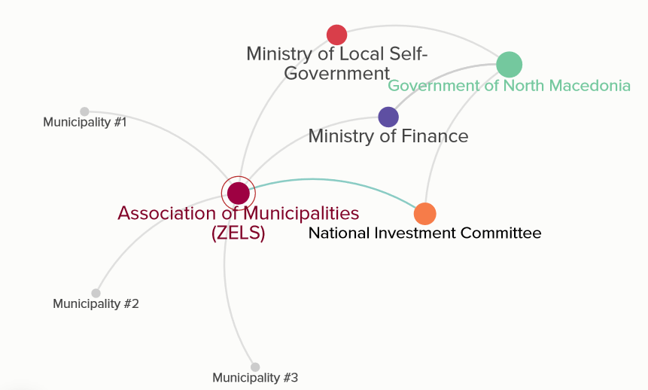

The Quest for a Balanced Regional Development

Ensure the legal minimum of policy funding. Development plans and strategies need a financial envelope to be responsive to the needs of the local and regional conditions. They must secure the appropriate policy funding, at least in the amount of 1% of country’s GDP as prescribed by the law.

Coordination with the Ministry of Finance. The Strategy for Regional Development must be closely coordinated with the Commission for Monitoring the Development of the System of Decentralization and the Ministry of Finance. Part of the intergovernmental transfers (the equalization grants, in particular, and a portion of the general-purpose VAT grant) must be aligned with the Strategy for Regional Development.

Screening Stakeholder Expectations, UNDP, March 2021.
https://www.multiact.eu/wp-content/uploads/2020/02/D9.1.pdf
We conducted 12 interviews (1:1) with: Mr. Goran Milevski, Minister of Local Governance, Mr. Ace Kocevski, President of the Committee for Finance of ELS & Mayor of municipality Veles, Dusica Perishikj, Director of ZELS, Mr. Maksim Dimitrievski, Mayor of municipality Kumanovo, Mr. Ango Angov, Mayor of municipality Dojran, Mr. Milaim Ameti, Chief of Staff of Vice Prime Minister for Economy, Mr. Zoran Jankulovski, Director of the Association for finance workers, Prof. Dr. Suzana Makreshanska, Faculty of Economics – Skopje, UKIM, Mr. Fisnik Shabani, Project Specialist in Democratic Governance, UNDP, the Director of Bureau for Regional Development, Mr. Ramiz Rexhepi, Mr. Dimitar Karatashev, Chief of Cabinet of the Mayor of Karpos, and Ms. Dushica Perishic, President of the Association of Units of Local Governments (ZELS).
The LGLD offers support at local level in the following processes: (1) creating recommendations for development and implementation of regional development strategies and relevant training for local officials and leaders; (2) aiming the regional plans toward the needs of minority groups, local economic development, sustainable environment, and disaster risk resilience; and (3) participation of the community members, civil society, and the private sector in the local development plans.
Nomenclature of Territorial Units for Statistics (NUTS).
The previous strategy for the balanced regional development referred to the 2009-2019 period and the most recent one refers to the 2021-2031 period.
Interviews with representatives from the municipalities of Karpoš, Ilinden, Mavrovo-Rostuse, and Ohrid.
However, the respondents would prefer not to reveal their names.
Article 81 (Association of municipalities in North Macedonia) stipulates that: “(1) The association of municipalities, in which more than two thirds of the municipalities from the entire territory of North Macedonia joined to protect and improve their common interests has the right to: - cooperate with the Government on issues that are important for the municipalities; - initiate enactment of the laws pertinent to improving the local self-government; - offers proposals for the formulation of the Budget of the Republic of North Macedonia on the part relating to the allocation of funds to perform their functions stipulated by the law […].”
“Framework to Analyze the Quality of Stakeholder Engagement in implementation and follow-up of the 2030 Agenda”.
Mainstreaming into National Planning Process – UNDP.
https://search.coe.int/cm/Pages/result_details.aspx?ObjectId=09000016807509dd
http://mls.gov.mk/images/laws/zakoni/Zakon%20za%20ramnomeren%20regionalen%20razvoj.pdf
http://lokalnademokratija.mk/mk-mk/%D0%B3%D1%80%D0%B0%D0%BD%D1%82%D0%BE%D0%B2%D0%B8/%D0%BD%D0%BE%D0%B2%D0%BE%D1%81%D1%82%D0%B8-%D0%BE%D0%B4-%D0%B3%D1%80%D0%B0%D0%BD%D1%82%D0%B8%D1%81%D1%82%D0%B8%D1%82%D0%B5/artmid/739/articleid/132/%D0%9F%D1%80%D0%BE%D0%B3%D1%80%D0%B0%D0%BC%D0%B0-%D0%A4%D0%BE%D1%80%D1%83%D0%BC%D0%B8-%D0%B2%D0%BE-%D0%B7%D0%B0%D0%B5%D0%B4%D0%BD%D0%B8%D1%86%D0%B8%D1%82%D0%B5-2006-2016
http://opstinski.mk/login/index.php
http://opstinskisoveti.mk/en/
https://vlada.mk/node/24186
Local Development Steering Committee
Thematic Steering Committees
Stakeholder Engagement Platform
Stakeholder Engagement Platform
S. Arnstein: A ladder of citizen participation; Journal of the American Institute of Planners; 1969
https://vlada.mk/node/24186
Mainstreaming into National Planning Process - UNDP

